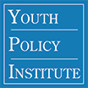
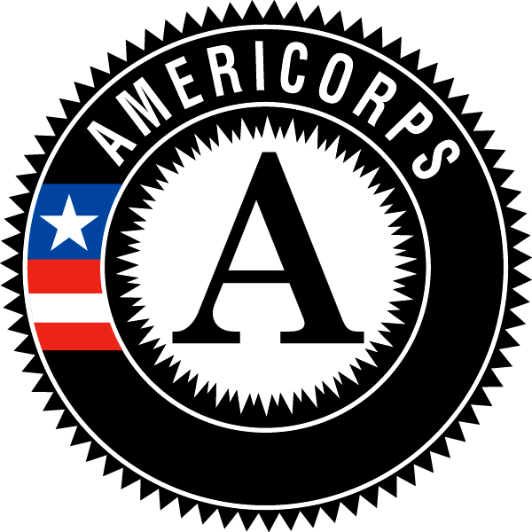
Hunger for Change Walk-A-Thon!

Saturday, May 10
Name: |  |  | Number of Laps Completed:
Dear Potential Sponsor,
I am participating in the Youth Policy Institute’s AmeriCorps Hunger 4 Change Walk-A-Thon. All proceeds will help fund Share Our Strength No Kid Hungry. No Kid Hungry works to end childhood hunger through Access, Education, and Awareness. You can sponsor me for an amount per lap and can name a maximum amount that you are willing to contribute. You can also make a flat pledge which is a one-time, flat amount donation. After the walk-a-thon, you will be contacted with the number of laps I walked and asked to make your contribution online. Checks made out to Share Our Strength. All contributions are tax-deductible.
I plan to walk at least _______ laps for Hunger 4 Change.
Thank you!
 | Name of Sponsor | Email | Pledge per Lap (Ex: $1.00) | Max Pledge | Flat Pledge | Paid? (Y or N)  And Form of Payment
1 | Ex. Jeanne Kelber | jexample@gmail.com | $2.00 | $40.00 |  | Y- check/cash/online
2
3
4
5
6
7
8
9
10
11
12
13
14
15
16
17
18

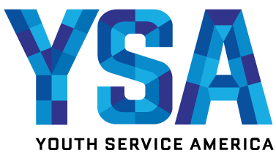
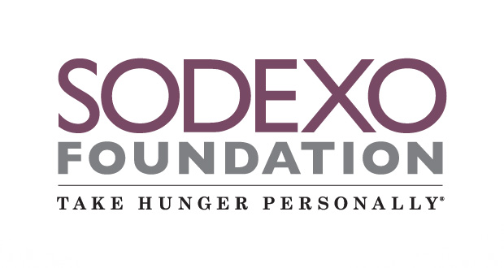
Participants:
To reach our goal, we hope that each participant finds 10 sponsors!
Please bring this form on the walk-a-thon day, Saturday, May 10.

